**Zenius8**

**Operating System Conversion Guide**

Windows Mobile 🡪 Android

V 1.0

# NAUTIZ X8 CONVERTING FROM WINDOWS OS TO ANDROID OS

NOTE: This feature is available only on controllers purchased with “Windows Embedded Handheld”

NOTE: In attach with the Guide all the necessary files

1. LATEST WINDOWS VERSION

Make sure you are running the last Windows version before starting the converting.

It is possible to find the latest version on the following link:

<https://www.handheldgroup.com/support-rugged-computers/knowledgebase-KB/11442/>

(English OS 78.07 C1)

Once downloading, extract the folder on the controller, copy also the “PFU” file in the root folder of the internal storage.

Select the “PFU” file and start the update

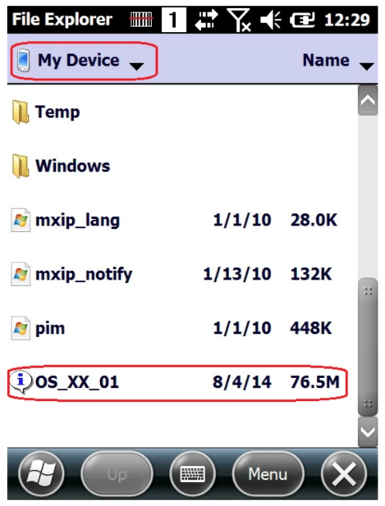

1. CREATE A BOOTABLE MICRO-SD CARD

Before continuing with the procedure, create a bootable micro-SD card.

Download “Rufus” software on the following link:

<https://rufus.akeo.ie/>

Click the file and select “Run as Administrator”

Select your micro-SD card in the “Device” row

File System setting on “Fat32”

Check the “Quick Format” and “Create a bootable disk”

Select “FreeDOS” for the bootable card

Press “Start” and wait till the procedure is complete

Make sure you are selecting the right settings as the following image

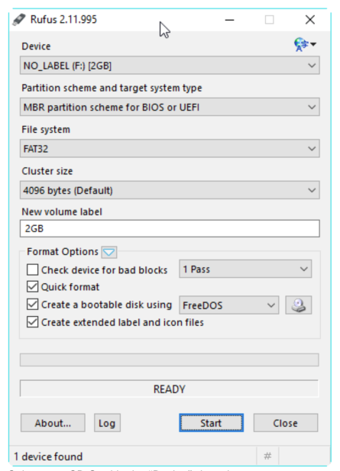

1. LATEST ANDROID VERSION

Install the latest Android version from the GeoMax Partner Area

<http://www.geomax-positioning.com/Partner-Area-Login_1186.htm>

Field Controllers 🡪 Zenius8 🡪 Software

Install also the TOOL file from the following link:

<https://www.handheldgroup.com/support-rugged-computers/knowledgebase-KB/12466/>

1. MICRO-SD

Extract the zip folder in the micro-SD card, importing also the TOOL file

Make sure that the files list is complete:

- 88_XX_XXX.PFU

- MLO

- u-boot.bin

- Update2Android_Vx.x.x.exe

1. Launch “File Explorer” and look for the “Storage Card” folder

Select the file “Update2Android” as the following image

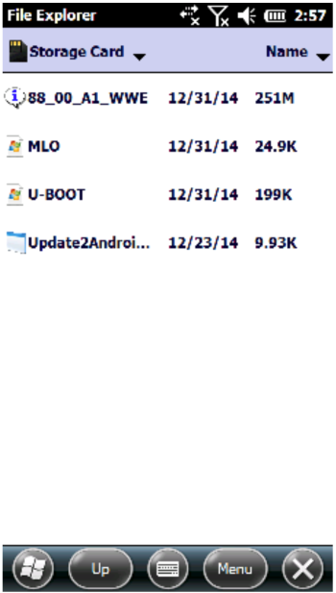

1. Press and hold “Power button + F1 + F2” for more than 8 seconds.

Make sure that no other buttons are pressed at the same time.

When you feel the unit vibrate, release the button.

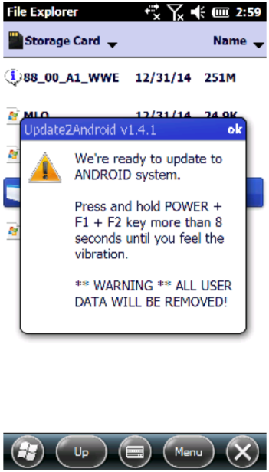

The controller will update and reboot automatically.

The new home screen should be Android.